USE CASE DIAGRAM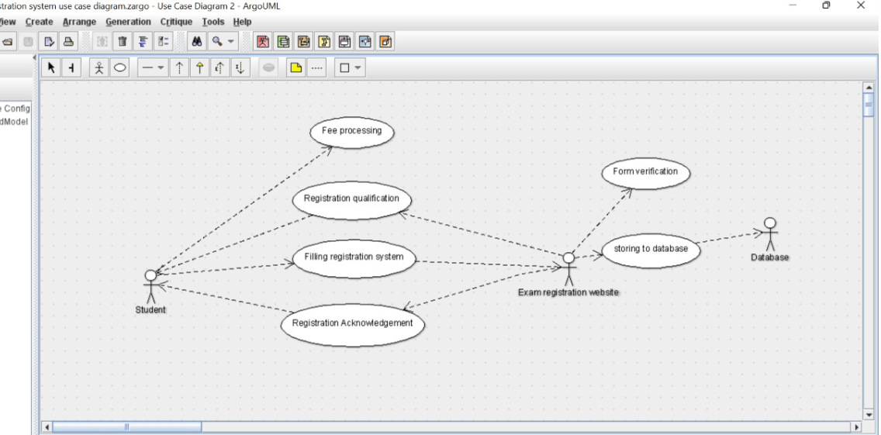

CLASS DIAGRAM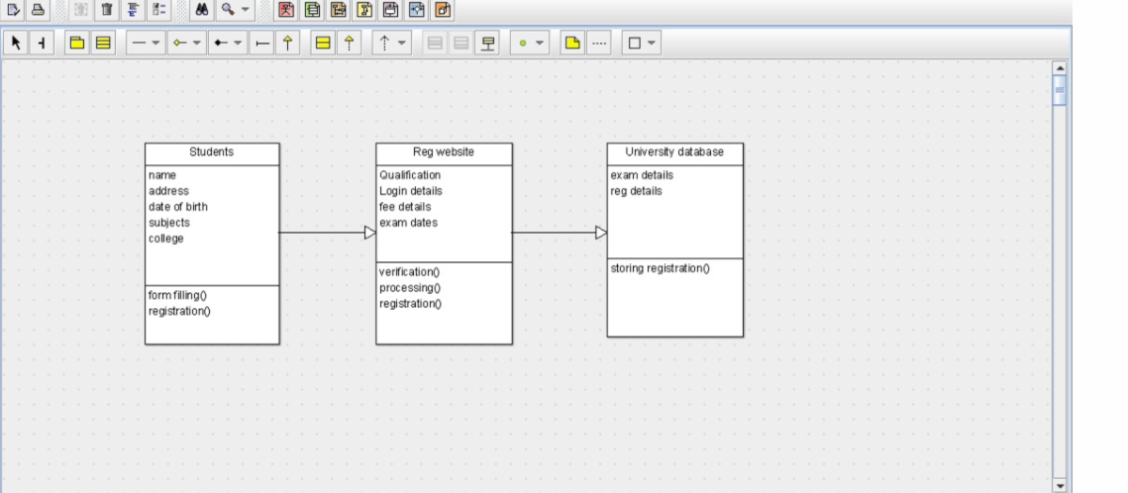

ACTIVITY DIAGRAM

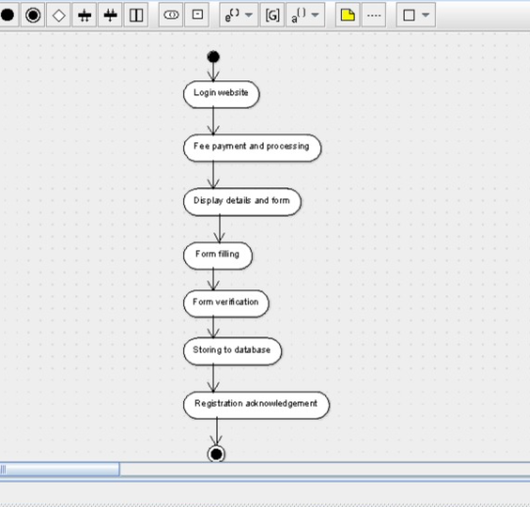

public class Students extends Reg website {

public name;

public address;

public date of birth;

public subjects;

public college;

public ;

public void form filling() {

}

public void registration() {

}

}public class Reg website extends University database {

public Qualification;

public Login details;

public fee details;

public exam dates;

public void verification() {

}

public void processing() {

}

public void registration() {

}

}

public class University database {

public exam details;

public reg details;

public void storing registration() {

}

}

STATE CHART DIAGRAM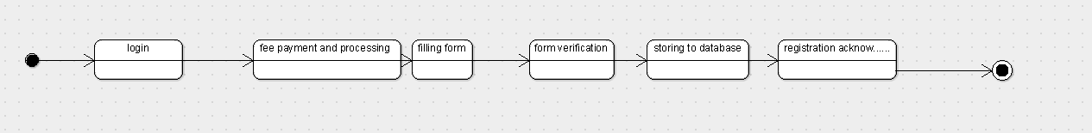

COMPONENT DIAGRAM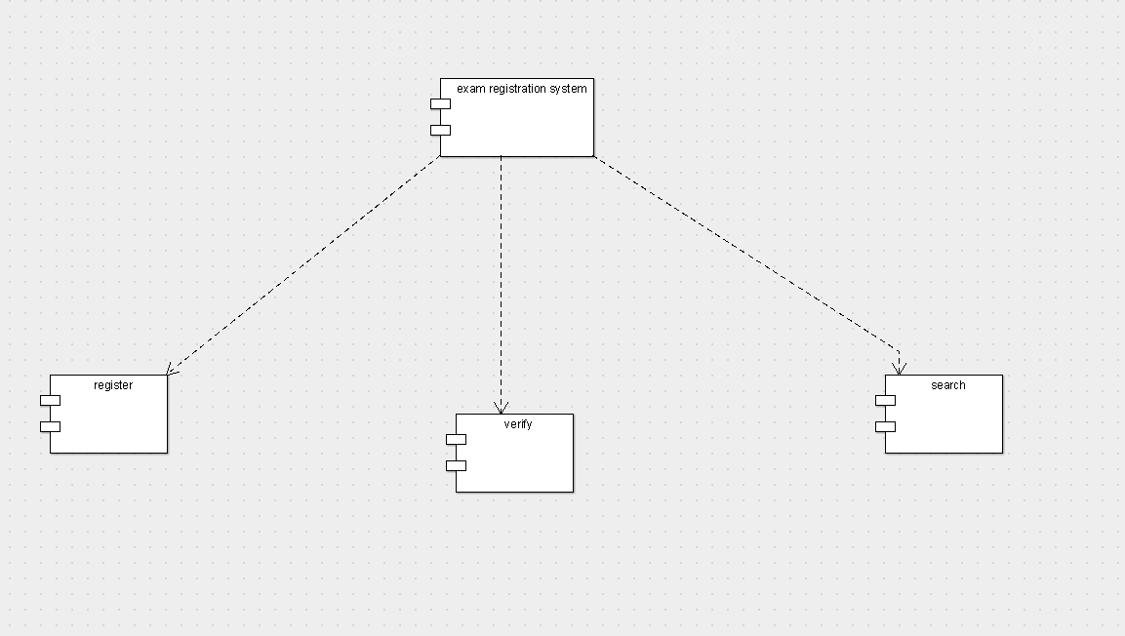

DEPLOYMENT DIAGRAM